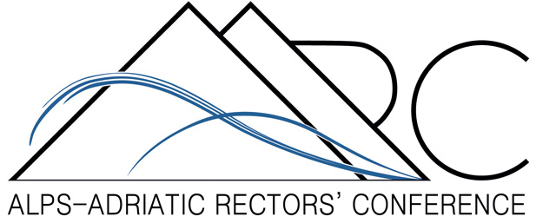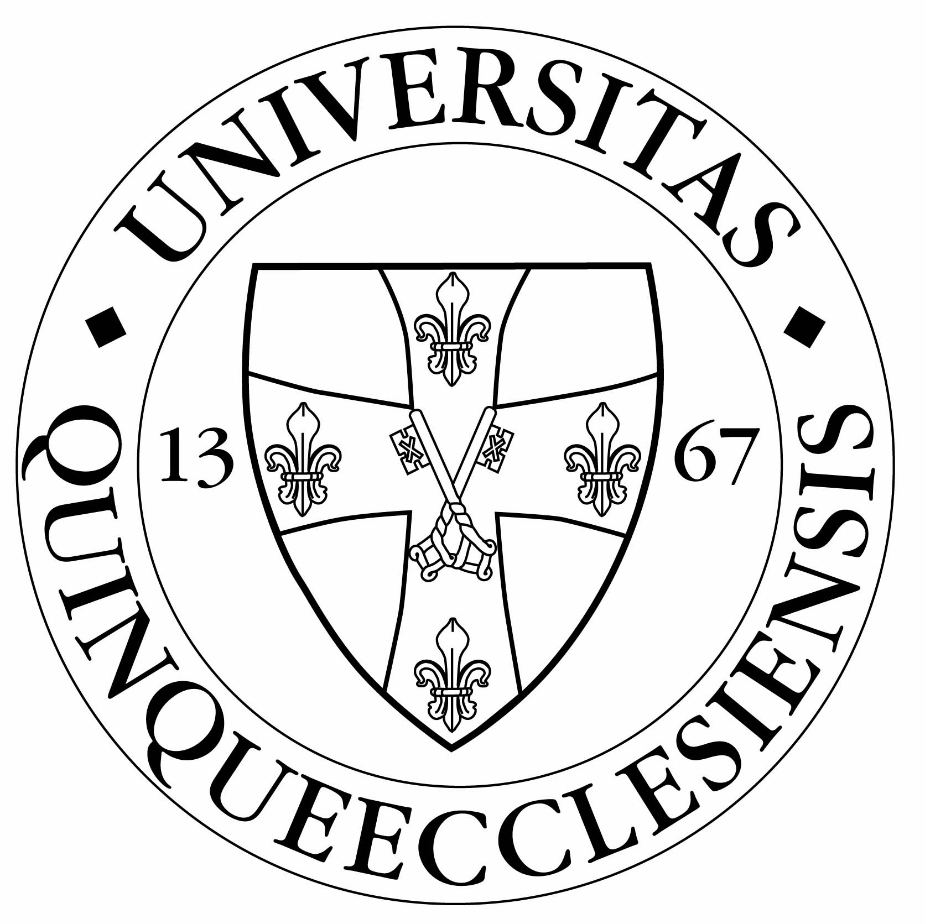

ALPS ADRIATIC SCHOLARSHIP IN HUNGARY
FOR THE AUTUMN SEMESTER 2013/2014

UNIVERSITY OF PÉCS – CITY OF PÉCS

The City of Pécs, Hungary and the University of Pécs, Hungary jointly announce two Alps Adriatic Scholarships in Hungary for the autumn semester 2013/2014 for the period of 4 to 5 months with the amount of 1.000 – 1.000 euro for the total period of the scholarship to be spent on credit courses at one of the faculties of the University of Pécs.

Applicants should be enrolled in one of the universities that are full members of the Alps Adriatic Rectors Conference at the time of application (http://www.alps-adriatic.com), having accomplished at least four semesters with an average score „good or excellent”.

The application materials in English should include:

- Application form
- Curriculum Vitae
- short study plan to be accomplished during the scholarship at UP
- two letters of reference - one from the sending institute and one from a professor
- Transcript of records (subjects and grades)
- applicant’s self-declaration about their language proficiency
- short description of applicant’s research, scholarly or artistic achivements (publications if applicable)
- applicant’s declaration of their obligation to submit a study report within 30 days after finishing the scholarship period
- applicant’s statement that they are ready to spread information concerning both the City of Pécs and the University of Pécs, possibly in the form of popular lectures

Further information on the University of Pécs and the courses can be found at (www.pte.hu) or inquires can be sent to Eszter Sándorfi (sandorfi.eszter@pte.hu) in the Rector’s Office/International Relations Department of the University of Pécs (www.iro.pte.hu).

Complete applications should be sent by 1 July 2013 to the following address:

Eszter Sándorfi
Rector’s Office/International Relations Department
University of Pécs
Vasvári Pál u. 4.
H-7622 Pécs
Tel: +36 72 /501-509
Fax: +36 72/251-527
E-mail: sandorfi.eszter@pte.hu

